**Cache mapping:** [**https://www.youtube.com/watch?v=QcAaP5V2Gpc**](https://www.youtube.com/watch?v=QcAaP5V2Gpc)

**Direct Mapping**

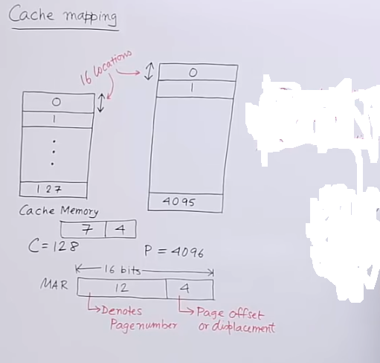

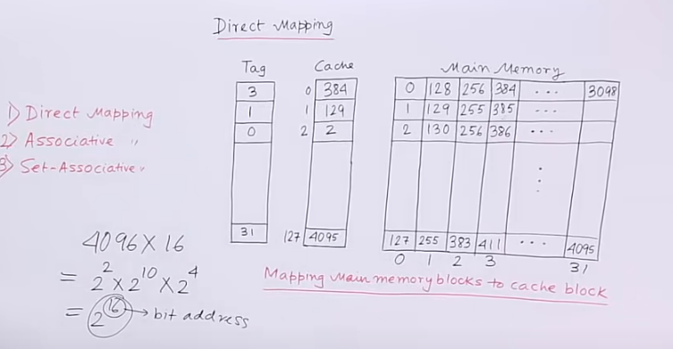

Associative mapping

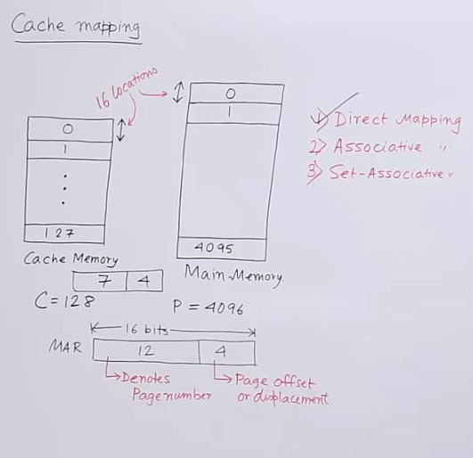

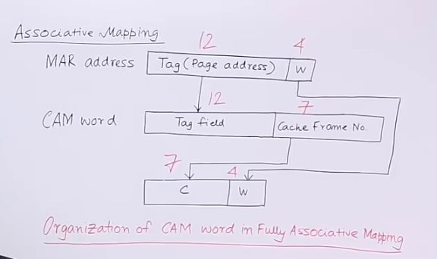

**Set Associative mapping: https://www.youtube.com/watch?v=6dOsTTjzzrU**

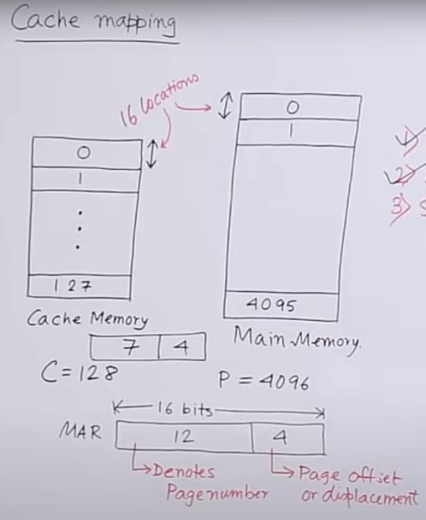

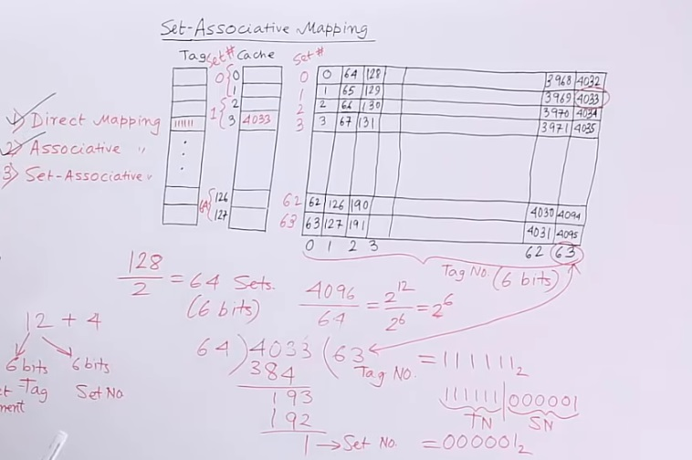

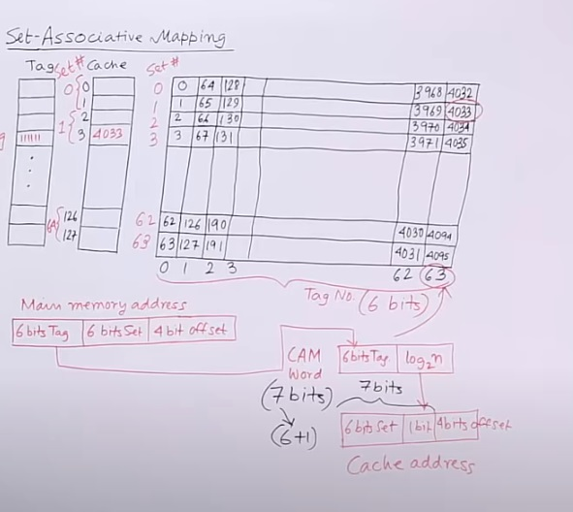

**Virtual memory:**

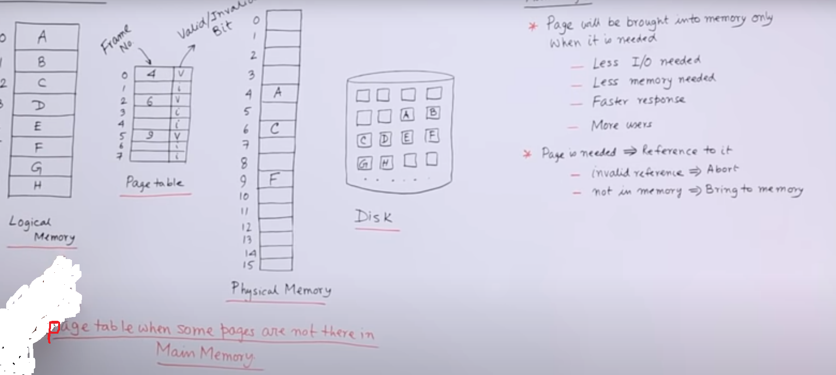

**Page Fault: https://www.youtube.com/watch?v=lgmws9oraXE**

